VIDHYA.R

192572153

SIMATS ENGINEERING

ASSESSMENT TOOL 2

COURSE NAME: Artificial Intelligence COURSE CODE: CSA17

COURSE OUTCOME COVERED

CO2: Experiment search and game-solving techniques such as Greedy Search, A*, CSP, Minimax, and Alpha-Beta pruning with heuristic functions for solving complex AI problems efficiently. (BL3)

Assessment Tool Weightage: 20%

Duration: 1 Hour
QUESTIONS: 5 Total Marks:50

Annexure A

Scenario Based Assignment

Code of Conduct:

I VIDHYA.R(192572153) (Name / Reg No) certify that this submission is my original work and that I have adhered to the guidelines specified for this assessment.
I understand that any violation of academic integrity rules will result in disciplinary action.

Signature of the student:

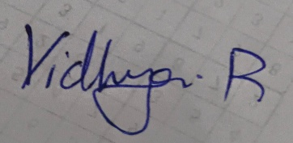
Annexure A

Scenario Based Assignment
- Scenario : A government deploys AI-powered drones to deliver emergency medicines in a flood-affected region. The environment is highly dynamic—roads may suddenly become inaccessible, and weather conditions affect travel cost. The drone has access to: A heuristic estimate (straight-line distance), Partial real-time updates about blocked paths and Variable movement costs depending on terrain and weather. However, due to urgency, the drone must quickly decide routes with minimum delay and risk.
Tasks:
  - Explain how Greedy Best-First Search would behave in this scenario and discuss its strengths and weaknesses under uncertainty
  - Explain how A* would handle the same situation, including how it balances cost and heuristic
  - Analyze the impact of heuristic accuracy on both algorithms
  - Discuss how dynamic changes (blocked paths) affect search performance
  - Recommend the most suitable algorithm and justify your decision considering real-time constraints, optimality, and safety
- Scenario: A smart city implements an AI system to optimize traffic signal timings across hundreds of intersections. The objective is to minimize Total waiting time, Fuel consumption and Traffic congestion. The system must continuously adjust signals based on traffic flow. However the search space is extremely large, traffic patterns change dynamically and the system may get stuck in locally optimal solutions
Tasks. Formulate this as an optimization problem and explain why traditional search is inefficient
  - Explain how Hill Climbing would work in this scenario and identify its limitations
  - Discuss issues like local maxima, plateaus, and ridges with real-world interpretation
  - Explain how Simulated Annealing or Genetic Algorithms can overcome these limitations
  - Recommend the best approach and justify your choice based on scalability and adaptability
- Scenario: An autonomous rover is deployed on Mars to explore unknown terrain. It must: navigate safely to collect samples, avoid hazards (craters, rocks), operate with limited sensing capability and make decisions without a complete map. The rover updates its knowledge as it explores, making this a real-time decision-making problem.
Tasks:
  - Explain why this problem requires an online search agent instead of offline search
  - Analyze the challenges of partial observability and dynamic environments

  - Describe how the rover builds and updates its internal model
  - Compare online search with uninformed and informed search strategies
  - Justify the most suitable approach considering uncertainty, adaptability, and safety
- Scenario: A university is designing an AI system to automatically generate exam timetables. The system must satisfy multiple constraints: No student should have overlapping exams, Limited number of exam halls, Certain subjects must be scheduled before others, Faculty availability constraints, Special accommodations for some students, The complexity increases as the number of courses and students grows.
Tasks :
Formulate the problem as a Constraint Satisfaction Problem (CSP)
  - Clearly define variables, domains, and constraints with explanation
  - Explain how backtracking search works in this scenario
  - Discuss how constraint propagation (e.g., forward checking) improves efficiency
  - Analyze real-world challenges and justify the best strategy for scalability

- Scenario: Strategic Game AI for Real-Time Decision Making (Minimax & Alpha-Beta Pruning) A gaming company is developing an AI opponent for a real-time strategy game. The AI must complete against human players, Make decisions within strict time limits, Evaluate complex game states with multiple possible moves, The decision tree is extremely large, making computation expensive.
Tasks:
  - Explain how the Minimax algorithm models this problem
  - Analyze the computational challenges of large game trees
  - Explain how Alpha-Beta pruning improves efficiency with detailed reasoning
  - Design an evaluation function and justify the factors considered
  - Recommend a strategy for balancing optimality and real-time performance

RUBRICS FOR CALCULATION

Criteria | Weightage (%) | Level 4 (Exemplary) | Level 3 (Proficient) | Level 2 (Developing) | Level 1 (Beginning)
Understanding of Scenario | 20% | Demonstrates clear and complete understandin g of the scenario and context | Shows good understanding with minor gaps | Partial understanding; misses key aspects | Misinterprets or fails to understand the scenario
Identification of Key Issues | 20% | Accurately identifies all relevant issues and factors involved | Identifies most key issues with minor omissions | Identifies limited issues; some irrelevant points | Unable to identify key issues
Application of Concepts | 25% | Applies appropriate concepts effectively to address the scenario | Applies concepts with minor errors | Limited or partially correct application | Unable to apply relevant concepts
Decision Making | 20% | Makes  well-reasoned  , logical decisions with strong rationale | Makes reasonable decisions with some justification | Makes weak decisions with limited justification | No clear decisions made or rationale provided
Clarity of Response | 15% | Response is clear, structured, and logically presented | Generally clear with minor issues | Somewhat unclear or poorly structured | Disorganized and difficult to understand
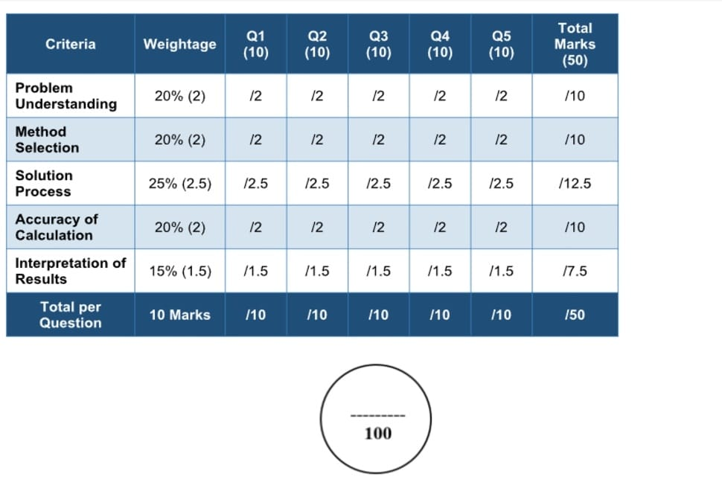

ANSWERS:

1. AI-Powered Drone for Emergency Medicine Delivery (Greedy Best-First Search & A*)
i. Greedy Best-First Search (GBFS)
Greedy Best-First Search selects the path that appears closest to the goal using only the heuristic function h(n) (straight-line distance).
Working
- Calculates only the estimated distance to the destination.
- Chooses the node with the smallest heuristic value.
- Ignores the actual travel cost already incurred.
Strengths
- Very fast decision-making.
- Requires less computation.
- Suitable when emergency response is more important than finding the perfect route.
- Quickly reaches the destination if the heuristic is accurate.
Weaknesses
- May choose blocked roads because it ignores actual path cost.
- Can produce unsafe or expensive routes.
- Does not guarantee the shortest or safest path.
- Performs poorly in highly dynamic environments.

ii. A* Search
A* combines both the actual path cost and estimated remaining distance.
Formula
f(n) = g(n) + h(n)
Where
- g(n) = Actual travel cost from start to current node
- h(n) = Estimated cost from current node to goal
Working
- Evaluates both travelled distance and estimated remaining distance.
- Updates routes whenever new information (blocked roads, weather) becomes available.
- Searches for the minimum-cost path.
Advantages
- Finds optimal path if heuristic is admissible.
- Considers weather and terrain costs.
- Produces safer routes.
- Adapts better to changing environments.
Disadvantages
- Higher computation than GBFS.
- Requires more memory.
- Slightly slower.

iii. Impact of Heuristic Accuracy
Accurate Heuristic
- GBFS reaches destination quickly.
- A* explores fewer nodes.
- Better performance and lower computation.
Inaccurate Heuristic
- GBFS may completely miss better routes.
- A* still finds the optimal path but explores more nodes.
- Search time increases.

iv. Effect of Dynamic Changes (Blocked Roads)
Greedy Best-First Search
- May continue toward blocked paths.
- Requires restarting search frequently.
- Performance degrades significantly.
A*
- Updates path costs.
- Recalculates better routes.
v. Recommended Algorithm
Recommended: A*
Justification
- Considers both distance and travel cost.
- Produces optimal routes.
- Better handles weather and blocked roads.
- Improves safety during emergency delivery.
- Suitable despite slightly higher computation because safety is critical.

2. Smart City Traffic Signal Optimization

Optimization Problem
Objective
Minimize
- Total waiting time
- Fuel consumption
- Traffic congestion
Variables
- Signal timings
- Green-light duration
- Signal sequence
Constraints
- Traffic flow changes continuously.
- Large number of intersections.
- Different traffic densities.

Why Traditional Search is Inefficient
Traditional search
- Explores every possible signal combination.
- Search space grows exponentially.
- Computationally expensive.
- Cannot react in real time.

i. Hill Climbing
Working
- Starts with current signal timing.
- Evaluates neighboring solutions.
- Moves to the better neighboring solution.
- Stops when no better solution exists.
Advantages
- Simple.
- Fast.
- Low memory.
Limitations
- Gets trapped in local optimum.
- Cannot guarantee global optimum.
- Sensitive to initial solution.

ii. Local Maxima, Plateaus and Ridges
Local Maxima
Traffic improves slightly but better solutions exist elsewhere.
Example:
One intersection becomes efficient while nearby intersections become congested.

Plateau
Many neighboring solutions have equal performance.
Example:
Changing signal timing by 2 seconds produces no noticeable improvement.

Ridge
Best improvement requires moving diagonally through several variables.
Example:
Changing two adjacent intersections together improves traffic, but changing only one does not.

iii. Simulated Annealing and Genetic Algorithm
Simulated Annealing
- Occasionally accepts worse solutions.
- Escapes local maxima.
- Gradually reduces randomness.
- Better global optimization.

Genetic Algorithm
Working
- Creates population of solutions.
- Selects best solutions.
- Applies crossover.
- Applies mutation.
- Produces improved generations.
Advantages
- Searches many solutions simultaneously.
- Escapes local optima.
- Suitable for large optimization problems.
- Highly scalable.

iv. Recommended Approach
Recommended: Genetic Algorithm
Justification
- Excellent scalability.
- Handles dynamic traffic.
- Finds near-optimal solutions.
- Works efficiently with many intersections.
- Easily integrates real-time traffic data.

3. Mars Rover (Online Search Agent)
i. Why Online Search?
Offline search requires complete knowledge before starting.
Mars rover
- Has incomplete map.
- Learns environment while moving.
- Encounters unknown obstacles.
Therefore, online search is necessary.

ii. Challenges
Partial Observability
- Limited sensor range.
- Hidden obstacles.
- Unknown terrain.
Dynamic Environment
- Dust storms.
- Moving rocks.
- Sensor uncertainty.
- Communication delay.

iii. Internal Model
The rover continuously updates its knowledge.
Steps
- Sense surroundings.
- Detect obstacles.
- Update terrain map.
- Store visited locations.
- Plan next action.
- Repeat.
The internal model gradually becomes more accurate.

iv. Comparison
Feature | Uninformed Search | Informed Search | Online Search
Complete map | Yes | Yes | No
Uses heuristic | No | Yes | Optional
Learns while moving | No | No | Yes
Suitable for Mars | No | Limited | Yes

v. Best Approach
Recommended: Online Search Agent
Justification
- Works with incomplete information.
- Adapts continuously.
- Learns environment.
- Avoids hazards.
- Maximizes rover safety.

4. University Exam Timetable (Constraint Satisfaction Problem)
CSP Formulation
Variables
Each course represents one variable.
Example
- C1
- C2
- C3
- C4

Domains
Possible exam slots
Example
- Monday Morning
- Monday Afternoon
- Tuesday Morning
- Tuesday Afternoon

Constraints
- No student has overlapping exams.
- Limited exam halls.
- Faculty availability.
- Subject ordering.
- Special accommodation requirements.

i. Variables, Domains and Constraints
Variables represent courses.
Domains represent available exam slots.
Constraints eliminate invalid schedules.
The goal is to assign every course a valid slot.

ii. Backtracking Search
Working
- Assign first course.
- Check constraints.
- If valid, continue.
- If conflict occurs, undo assignment.
- Try another slot.
- Repeat until all courses are scheduled.
Advantages
- Guarantees valid timetable.
- Simple implementation.
Disadvantages
- Slow for large universities.

iii. Forward Checking
Forward checking removes invalid choices immediately.
Example
If Course A occupies Monday Morning,
then conflicting courses cannot use Monday Morning.
Benefits
- Detects failure early.
- Reduces search space.
- Speeds up scheduling.

iv. Real-World Challenges
- Thousands of students.
- Hundreds of courses.
- Limited halls.
- Faculty changes.
- Last-minute modifications.
Best Strategy
Use
- Backtracking
- Forward Checking
- Constraint Propagation
This combination greatly improves scalability.

5. Game AI (Minimax & Alpha-Beta Pruning)
i. Minimax Algorithm
Minimax assumes
- AI tries to maximize score.
- Human tries to minimize AI score.
The algorithm explores all possible moves.
Decision
Choose move with maximum minimum gain.

ii. Computational Challenges
Large games have
- Huge branching factor.
- Millions of possible states.
- High memory usage.
- Slow computation.
Real-time games cannot search the full tree.

iii. Alpha-Beta Pruning
Alpha-Beta Pruning removes branches that cannot influence the final decision.
Alpha
Best value found for maximizing player.
Beta
Best value found for minimizing player.
If
Alpha ≥ Beta
remaining branches are ignored.
Advantages
- Reduces search time.
- Explores fewer nodes.
- Produces same optimal result as Minimax.
- Enables deeper search.

iv. Evaluation Function
Example
Evaluation Score =
- +50 × Number of friendly units
- +40 × Resources collected
- +30 × Map control
- +20 × Health remaining
- −40 × Enemy advantage
- −30 × Unit losses
Factors
- Army strength
- Resource availability
- Territory control
- Remaining health
- Strategic position

v. Recommended Strategy
Recommended
Alpha-Beta Pruning + Evaluation Function (with depth limit)
Justification
- Same decision quality as Minimax.
- Much faster.
- Supports real-time decision making.
- Handles large game trees efficiently.
- Balances optimality and computation.

